Nipulini Tanjala Jayasinghe

National Institute of Business Management Master of Science in Data Science NIB2001CEM– Data Mining Semester 2 - 2026 Course Work
COMscDS252P-011 R P N T JAYASINGHE
s
Contents
Part 1: Market Basket Analysis 3
Introduction to Market Basket analysis 3
Objectives and Business Benefits 3
Dataset Description and Preprocessing 4
Dataset description 4
Data Cleaning 4
Basket Matrix Creation 5
Why Preprocessing was necessary 5
Association Rule Mining Process 6
Apriori Algorithm 6
Parameter Settings 6
Rule Generation process 7
Resulting Association Rules 7
Summary of rules 7
Important rules Identified 8
Visualizations, 8
Interpretation of Rules 10
Business Recommendations 11
Part 2: Clustering Analysis 13
2.1 Introduction to Clustering 13
Objective 1 – K- Means Clustering of Wine Data 13
Dataset Description 13
Data Preprocessing 14
Featuring and Scaling 14
Applying K-means Clustering 15
Cluster Evaluation Using Confusion Matrix 15
Interpretation of Results 16
Objective 2 – Determining the Optimal Number of Clusters 16
Introduction to cluster Validation 16
Elbow Method 17
Silhouette Analysis 18
Comparison of Candidate Cluster Models 18
Cluster means and Interpretations 19
Consistency of Clusters with Wine Quality 19
Objective 3 – Hierarchical Clustering 20
Introduction to Hierarchical Clustering 20
Single Linkage Clustering 20
Complete Linkage Clusterin 21
Average Linkage Clustering 22
Ward Linkage Clustering 23
Cophenetic Correlation Analysis 23
Conclusion of part 2 24

Part 1: Market Basket Analysis

Introduction to Market Basket analysis

Market Basket Analysis is a data mining technique which is used to identify relationships and purchasing patterns between products in transactional datasets. This technique is widely used in retail business to discover what the items that are frequently bought together are. These outcomes help business to improve their product placement, promotional activities and inventory management.
Association Rule Mining is one of the most popular approaches used in Market Basket Analysis. It gives a relationship in the form of rules such as:-
A B
This means that customer who purchase product A is also likely to purchase product B.
In this analysis the Apriori algorithm was used to identify frequent item sets and generate association rules from the Online Retail dataset. From that the measures such as support, confidence, and lift to determine the strength and the usefulness of the discovered rules.
This analysis was conducted using Python in Visual Studio Code with libraries including Pandas, Mlxtend, Matplotlib and Seaborn.

Objectives and Business Benefits
The main objective of this analysis is to identify meaningful purchasing patterns from customer transaction data using association rule. By discovering products that is commonly purchased together, businesses can make more effective marketing and operational decisions.
The potential business benefits of Market Basket Analysis include:
- Improving product recommendation systems
- Increasing cross-selling opportunities
- Designing effective promotional campaigns
- Optimizing product placement in stores
- Enhancing customer shopping experience
- Supporting inventory management decisions
- Increasing overall sales and profitability
For example, if customers frequently purchase two products together the businesses can place those products near each other or offer promotions to encourage additional purchases.

Dataset Description and Preprocessing

Dataset description
The Online Retail Dataset contains transaction records from a UK based online retil business. It mainly sells all occasion gifts. The time period of these transactions are December 2010 to December 2011.
Attribute | Description
Invoice No | Unique Transaction number
StockCode | Product Code
Description | Product Name
Quantity | Number of products purchased
InvoiceDate | Date and Time of transaction
Unit Price | Price per unit
Country | Customer Country
CustomerID | Unique Customer ID

This data set contains a large number of retail transactions and is suitable for association rule mining because each invoice represent a customer transaction containing a lot of purchasing items.

Data Cleaning
Data preprocessing was performed before applying association rule mining to improve data quality and ensure accurate rule generation.
The following preprocessing steps were carried out:
- Removal of Cancelled Transactions
Transactions with invoice numbers starting with the letter "C" were removed because they represent cancelled orders. These transactions do not reflect actual customer purchasing behavior and could negatively affect the analysis.

- Removal of Negative Quantities

Rows containing negative quantities were removed because they represent returned products rather than completed purchases.

- Removal of Missing Product Descriptions
Rows with missing values in the Description column were removed because product names are essential for identifying item relationships during association rule mining.
These preprocessing steps reduced noise and improved the reliability of the generated association rules.

Basket Matrix Creation
After cleaning the dataset the transactional data was transformed into basket matrix format suitable for the Apriori Algorithm.
The data was grouped by Invoice Number and Product Description to create a transaction & product matrix. Each row represented a transaction while each column represented a product.
The matrix is then converted into a binary format using one-hot encoding:
* 1 → product purchased
* 0 → product not purchased
This transformation is necessary because the Apriori algorithm requires transactional data in binary form to identify frequent item sets.

Why Preprocessing was necessary
Preprocessing is a critical step in data mining because poor quality data can lead to inaccurate or misleading patterns.
In this analysis, preprocessing was necessary to:
- Remove invalid transactions
- Reduce noise in the dataset
- Improve computational efficiency
- Ensure accurate association rule generation
- Convert transactional data into a suitable format for the Apriori algorithm
Without preprocessing the generated rules may not correctly represent customer purchasing behavior.

Association Rule Mining Process

Apriori Algorithm
The Apriori algorithm was used to identify frequent item sets in the transactional dataset. Apriori is one of the most widely used algorithms for association rule mining because it efficiently discovers relationships between products based on transaction frequency.
The algorithm works by first identifying individual items with high support values and then progressively generating larger item combiantions. Itemsets that do not satisfy the minimum support threshold are removed during the process.Apriori was selected for this analysis because it is simple, effective, and well-suited for market basket analysis tasks.

Parameter Settings
Several parameter settings were selected during rule generation to control the quality of the discovered rules.

Minimum Support:
Support measures how frequently an itemset appears in the dataset.
A minimum support threshold was used to eliminate rare item combinations that may not provide meaningful insights.

Confidence:
Confidence measures how likely the consequent item is purchased when the antecedent item is purchased
Higher confidence values indicate stronger association rules.

Lift:
Lift measures how much more likely two products are purchased together compared to random chance.
A lift value greater than 1 indicates a positive relationship between products.These measures were used together to identify strong and meaningful association rules.

Rule Generation process
The Apriori algorithm first generated frequent item sets from the transaction matrix. These frequent item sets were then used to generate association rules using confidence and lift measures.
Strong rules were filtered based on lift values greater than 1 and reasonable confidence levels. This helped identify product combinations with meaningful customer purchasing relationships.
The final rule set was sorted according to lift values to identify the strongest product associations.

Resulting Association Rules

Summary of rules
After applying the Apriori algorithm and generating association rules, a total of several meaningful product relationships were identified from the Online Retail dataset. The generated rules highlighted products that customers frequently purchase together during transactions.
The rules were evaluated using the following important measures:
- Support
- Confidence
- Lift
To identify the most meaningful relationships, rules with higher confidence and lift values were selected as strong association rules.The analysis generated approximately 184 association rules, and further filtering based on confidence and lift values identified the strongest and most business relevant product relationships.

Important rules Identified
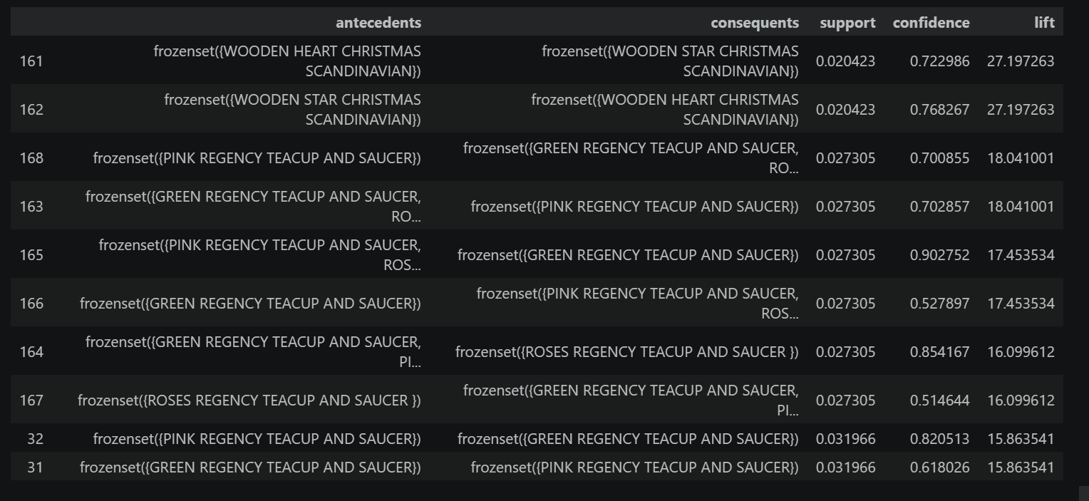
Several strong association rules were discovered during the analysis. The rules mainly involved products belonging to similar themes, decorative collections, and product variations.

The discovered rules suggest that customers tend to purchase products with similar themes & designs, or product collections together. For example, customers who purchase Scandinavian themed Christmas decorations are also highly likely to purchase other decorations from the same collection.
Similarly, customers purchasing one Regency teacup variation often purchase other matching variations. This indicates coordinated purchasing behavior among customers.
The high lift values indicate that these product relationships are significantly stronger than random purchasing behaviors

Visualizations
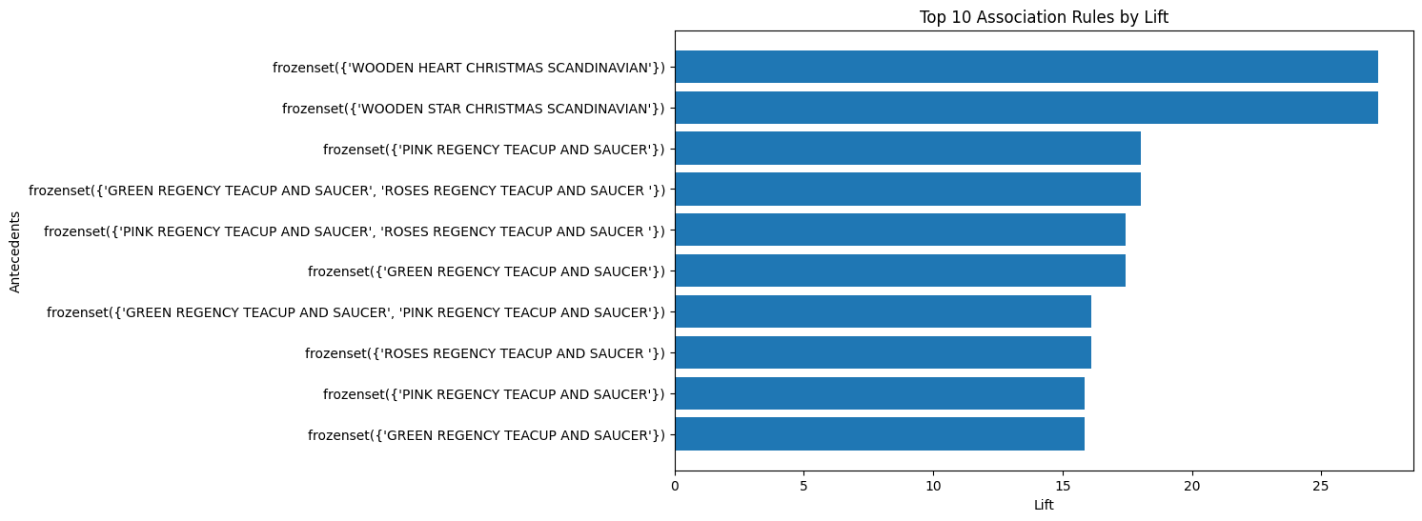
Top 10 Association Rules by Lift
The lift visualization highlights the strongest product relationships discovered during the analysis. Rules with higher lift values indicate stronger associations between products.The graph shows that several decorative and themed products have very high lift values, suggesting strong complementary purchasing behavior.
Support vs Confidence Scatter Plot
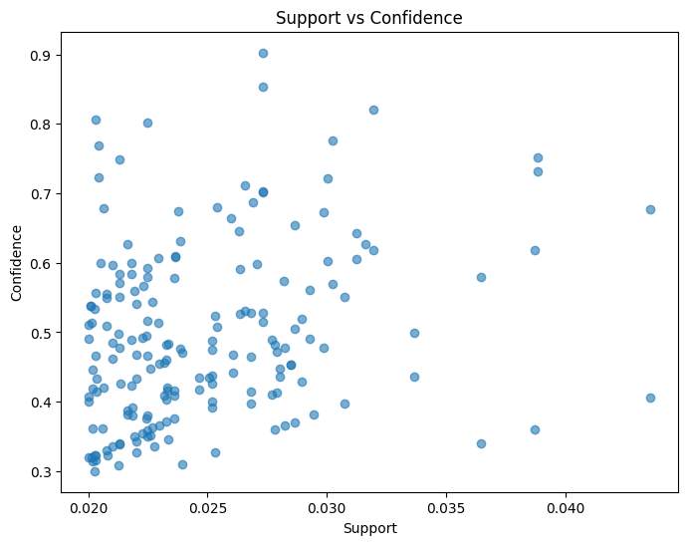

The scatter plot illustrates the relationship between support and confidence values of the generated rules.
The graph shows that some rules occur frequently with strong reliability, while others appear less frequently but still maintain high confidence levels. This helps identify rules that are both common and meaningful.

Interpretation of Rules
The analysis revealed that customers frequently purchase products belonging to the same product family, design collection, or decorative category together.
The discovered rules demonstrate strong purchasing patterns that can be used to improve:
- Product recommendation systems
- Cross-selling strategies
- Promotional campaigns
- Product placement strategies
- Online recommendation engines
The association rules also indicate that customer purchasing behavior in retail environments is strongly influenced by product similarity and complementary product relationships.

Business Recommendations
Based on the discovered association rules, several recommendations can be provided to the retail company.
- Product Bundling
Products with strong association relationships can be bundled together as promotional packages. For example different Regency teacup variations can be sold as combined product sets to encourage larger purchases.
- Recommendation Systems

The discovered rules can be integrated into recommendation systems on e-commerce platforms. Customers purchasing one product can be automatically recommended related products frequently purchased together.
- Store Layout & Product Placement
Products with high lift values should be placed close to each other in online or physical stores. This can increase customer exposure to related products and improve cross-selling opportunities.
- Promotional Campaigns
Products with strong purchasing relationships can be included in joint promotional campaigns or seasonal offers. For example, Scandinavian-themed Christmas decorations can be promoted together during holiday seasons.
- Inventory Management
Products that are frequently purchased together should be monitored carefully to maintain sufficient inventory levels. This can help reduce stock shortages and improve customer satisfaction.

This analysis successfully applied Market Basket Analysis techniques to identify purchasing patterns within the Online Retail dataset. After preprocessing and transforming the transactional data into basket matrix format the Apriori algorithm was use to generate frequent item sets and association rules.
The generated rules revealed strong relationships between several products, particularly among themed and complementary product categories. Evaluation measures such as support, confidence, and lift were used to identify meaningful and reliable rules.
The findings demonstrate that association rule mining can provide valuable insights for retail businesses by supporting recommendation systems, product placement strategies, promotional planning, and customer purchasing analysis.
Overall, the analysis showed that Market Basket Analysis is an effective data mining technique for discovering hidden relationships within large transactional datasets.

Part 2: Clustering Analysis

2.1 Introduction to Clustering
Clustering is a machine learning technique used to group similar observations into clusters based on their characteristics. Unlike supervised learning methods clustering do not use predefined class labels during the training process. Instead the algorithm automatically identifies hidden patterns and natural groupings within the data.
Clustering techniques are widely used in many fields such as marketing, image analysis, medical research, and scientific studies etc.In this analysis clustering techniques were applied to wine datasets in order to identify natural groupings based on the chemical properties of wines.
The analysis mainly focused on two clustering approaches:
- K-Means Clustering
- Hierarchical Clustering
K-Means clustering was used to partition wines into groups based on similarity & hierarchical clustering was used to analyze the hierarchical relationships among observations using dendrograms.
The analysis was conducted using Python with libraries including Pandas, Scikit-learn, Matplotlib, Seaborn, and SciPy.

Objective 1 – K- Means Clustering of Wine Data

Dataset Description
The Wine dataset used here contain with two separate datasets representing red wines and white wines. Each dataset includes several cochemical properties of wines long with wine quality information.
Attribute | Description
Fixed Acidity | Amount of fixed acids in the wine
Volatile Acidity | Amount of volatile acids
Citric Acid | Citric acid Concentration
Residual Sugar | Sugar remaining after fermenation
Chlorides | Salt Concentration
Free Sulfur Dioxide | Free Sulfur Dioxide level
Total Sulfur Dioxide | Total sulfur Dioxide Level
Density | Density of Wine
pH | Acidity Level
Quality | Wine Quality score
Sulphates | Sulphate Percen tage
Alcohol | Alcohol Percentage
The red wine and white wine datasets were stored in separate excel sheets and then it was combined into a single dataset for clustering analysis.

Data Preprocessing
Before applying clustering algorithms several preprocessing steps were performed to prepare the dataset for analysis.
First, the red wine and white wine datasets were imported separately from the Excel workbook. A new variable named ‘wine_type’ was then added to identify whether each observation belonged to the red wine dataset or the white wine dataset.
After adding the labels both datasets were combined into a single dataset using concatenation. Unnecessary empty columns that appeared during the import process were removed to improve data quality and avoid issues during clustering.
Preprocessing was important because clustering algorithms are sensitive to data quality and irrelevant attributes.

Featuring and Scaling
Feature scaling is one of the most important preprocessing steps in clustering analysis. K-Means clustering uses Euclidean distance to measure similarity between observations. Therefore, variables with larger numerical ranges can dominate the clustering process if scaling is not performed.
For example, sulfur dioxide values may range from 0 to 300, while pH values range only between 3 and 4. Without scaling, sulfur dioxide would have a much larger influence on distance calculations.
To avoid this issue, StandardScaler was applied to standardize the features. Standardization transforms the data so that each variable has:
- Mean = 0
- Standard Deviation = 1
Only the first eleven physicochemical attributes were used for clustering. The ‘quality’ and ‘wine_type’ variables are excluded because they are not clustering features.
Feature scaling improve the reliability and accuracy of the clustering process.

Applying K-means Clustering
K-Means clustering was applied to the scaled wine dataset in order to determine whether the algorithm could successfully separate red wines and white wines based on their chemical properties.
The K-Means algorithm works by dividing observations into a predefined number of clusters while minimizing the variation within each cluster.
Since the dataset naturally contains two wine categories, the number of clusters was set to:
K=2
The clustering model was implemented using the Scikit learn KMeans algorithm with a fixed random state value to ensure reproducibility of results.
After fitting the model to the scaled data cluster labels were generated for all wine observations.

Cluster Evaluation Using Confusion Matrix
To evaluate clustering performance the predicted cluster labels generated by K-Means were compared with the actual wine categories using a confusion matrix.
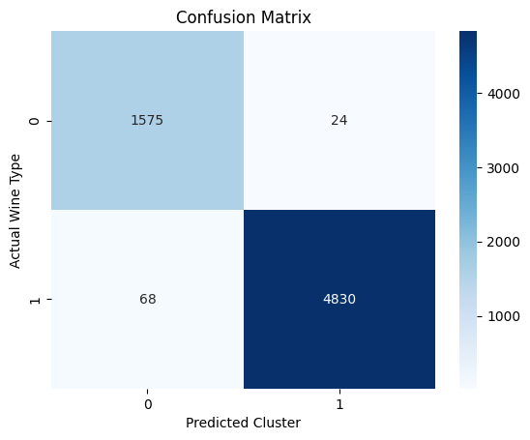

The confusion matrix showed that most wine observations were correctly assigned to their respective clusters.The clustering model achieved an accuracy of approximately: 98% which indicates excellent clustering performance.
The above confusion matrix demonstrates that red wines and white wines have clearly distinguishable chemical characteristics, allowing K-Means clustering to successfully separate the two categories.

Interpretation of Results
The clustering results indicate that the physicochemical properties of wines contain strong information that differentiates red wines from white wines.
The very high clustering accuracy suggests that K-Means clustering was highly effective for this dataset. Only a small number of wines were incorrectly assigned to clusters.
The analysis also demonstrates the importance of preprocessing and feature scaling in clustering tasks. Proper standardization help ensure that all variables contributed fairly to the clustering process.
Overall, Objective 1 showed that unsupervised clustering techniques can successfully identify meaningful natural groupings within wine datasets.

Objective 2 – Determining the Optimal Number of Clusters

Introduction to cluster Validation
Selecting an appropriate number of clusters is one of the most important decisions in clustering analysis. Choosing too few clusters may oversimplify the data, while choosing too many clusters may create unnecessary complexity.
To determine the optimal number of clusters for the wine dataset, two evaluation techniques were used:
- Elbow Method
- Silhouette Analysis
These methods help evaluate cluster compactness and separation quality.

Elbow Method
The Elbow Method was used to identify possible optimal cluster counts by analyzing the Within Cluster Sum of Squares (WCSS).
WCSS measures the total variation within clusters. Lower WCSS values indicate more compact clusters.
K-Means clustering was repeatedly applied for values of K ranging from 1 to 10, and the resulting WCSS values were plotted.
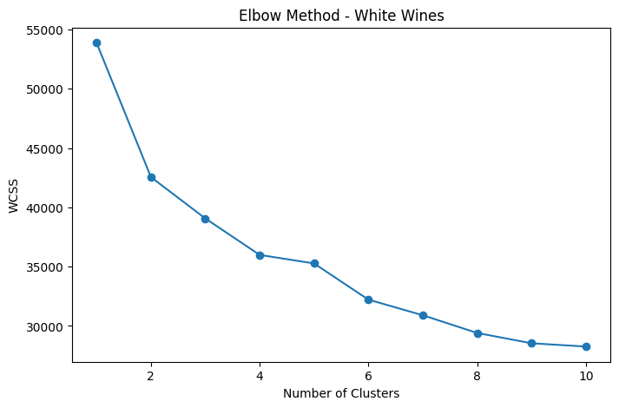
The graph showed a sharp reduction in WCSS values up to approximately K=4. After this point, the improvement became slower, indicating that K=3 and K=4 were reasonable candidate cluster counts.

Silhouette Analysis
Silhouette Analysis was used to further evaluate cluster quality and compare the candidate cluster counts identified using the Elbow Method.
The silhouette score measures how well observations fit within their assigned clusters compared to neighboring clusters. Higher silhouette scores indicate better cluster separation and compactness.
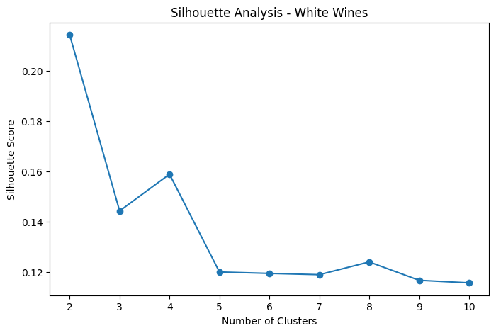
Silhouette scores were calculated for values of K ranging from 2 to 10.

The silhouette analysis showed that K=4 produced a higher silhouette score than K=3. Therefore, K=4 was selected as the final clustering model for the white wine dataset.

Comparison of Candidate Cluster Models
The Elbow Method suggested that the optimal cluster count lies around K=3 to K=4. Therefore, both candidate cluster counts were evaluated further using silhouette analysis.
Method | Suggested K
Elbow Method | 3 or 4
Silhouette Analysis | 4
Since K=4 produced the better silhouette score, it was selected as the final clustering solution.
The use of both validation methods helped improve the reliability of cluster selection.

Cluster means and Interpretations
After selecting K=4 as the final clustering model, the mean values of all attributes were calculated for each cluster in order to interpret cluster characteristics.
The cluster means helped identify difference in physicochemical properties among the generated wine groups.
Different clusters showed variations in variables such as alcohol level, acidity, sulphates and residual sugar indicating that the clustering algorithm successfully separated wines with different chemical compositions.

Consistency of Clusters with Wine Quality
The quality variable (column 12) was not used during clustering because K-Means clustering was an unsupervised learning technique. However, after clustering the average wine quality values were analyzed to evaluate the consistency and meaningfulness of the generated clusters.
The mean quality values for each cluster were calculated as follows:
Cluster | Mean Quality
0 | 6.14
1 | 5.62
2 | 5.49
3 | 5.91
The results indicate that the generated clusters show noticeable differences in average wine quality. Cluster 0 recorded the highest average quality score, while Cluster 2 recorded the lowest quality score.
This suggests that the clustering algorithm successfully identified groups of wines with different quality characteristics, even without directly using the quality variable during clustering. Therefore, the clustering structure is consistent with the information provided in column 12 of the dataset

Objective 3 – Hierarchical Clustering

Introduction to Hierarchical Clustering
Hierarchical clustering is an unsupervised machine learning technique used to group similar observations based on their distance or similarity. Unlike K-Means clustering, hierarchical clustering does not require specifying the number of clusters in advance. Instead, it gradually merges observations into clusters and represents the clustering structure using a dendrogram.
In this analysis agglomerative hierarchical clustering was applied to the white wine dataset in order to investigate the relationships among wine observations and compare different linkage methods.
Before applying hierarchical clustering, the dataset was preprocessed and standardized using feature scaling. Standardization was necessary because hierarchical clustering uses distance-based calculations, and variables with larger scales could dominate the clustering process if scaling was not applied.
The following linkage methods were investigated:
- Single Linkage
- Complete Linkage
- Average Linkage
- Ward Linkage
The performance of these methods was compared using dendrogram visualizations and cophenetic correlation analysis.

Single Linkage Clustering
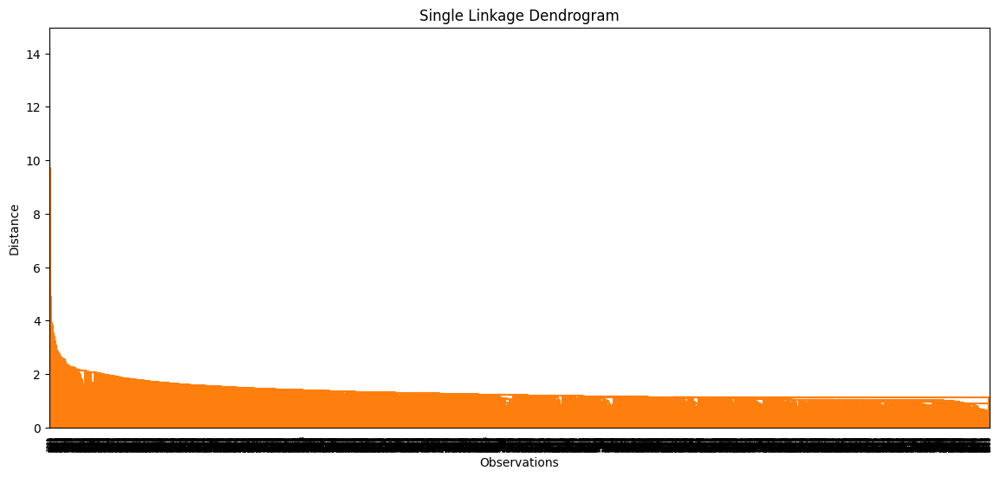
Single linkage clustering merge clusters based on the minimum distance between observations. In this method, the two closest observations from different clusters determine the cluster merging process.

The Single Linkage dendrogram showed a chaining effect where observations were merged sequentially based on minimum distances. As a result the dendrogram appeared elongated and less compact, making cluster boundaries difficult to identify clearly.
Although Single Linkage can detect irregular cluster shapes, it is sensitive to noise and tends to create long chains of observations rather than balanced clusters.

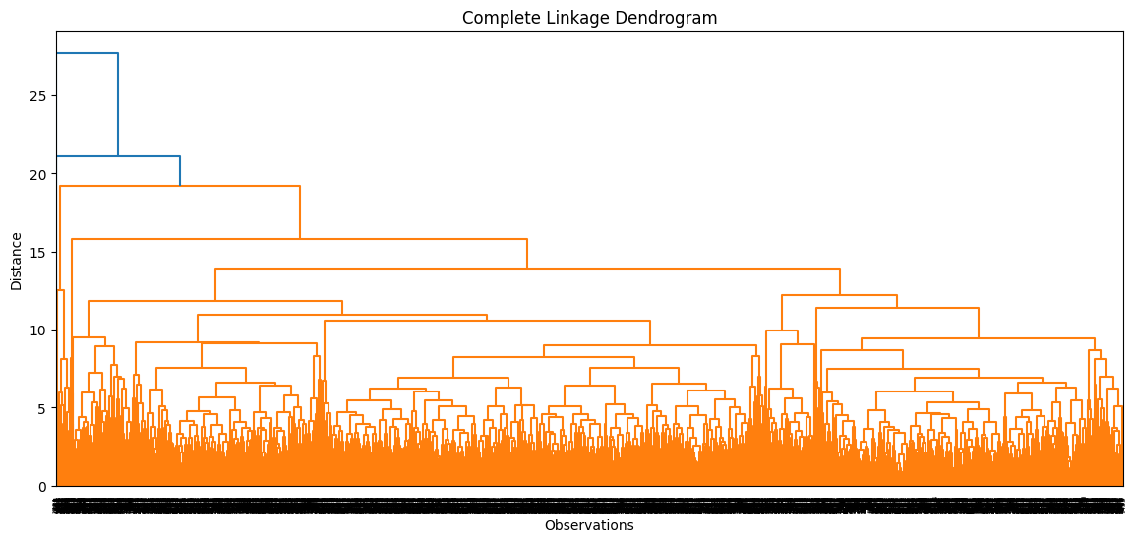
Complete Linkage Clustering

Complete linkage clustering merges clusters based on the maximum distance between observation in different clusters.
The Complete Linkage dendrogram produce more compact and clearly separated clusters compared to Single Linkage. Since Complete Linkage considers the maximum distance between clusters, it reduces the chaining effect and generates more balanced cluster structures.
This method produce improved cluster separation and more interpretable hierarchical relationships among white wine observations.

Average Linkage Clustering
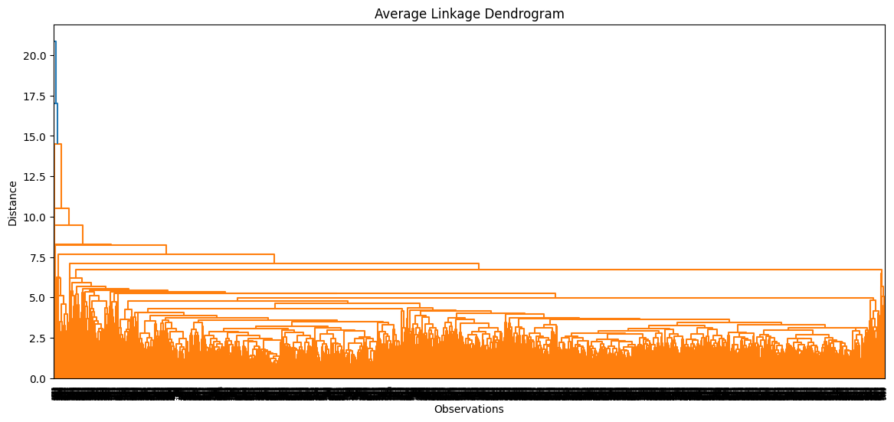
Average linkage clustering merges clusters based on the average distance between observations from different clusters.

The Average Linkage dendrogram produced a more balanced clustering structure by considering the average distances between clusters. Comparing to Single Linkage, it reduced the chaining effect while also avoiding the overly compact grouping behavior observed in Complete Linkage.
The dendrogram showed moderate and stable cluster formation, making it suitable for preserving overall similarity relationships within the white wine dataset.

\

Ward Linkage Clustering
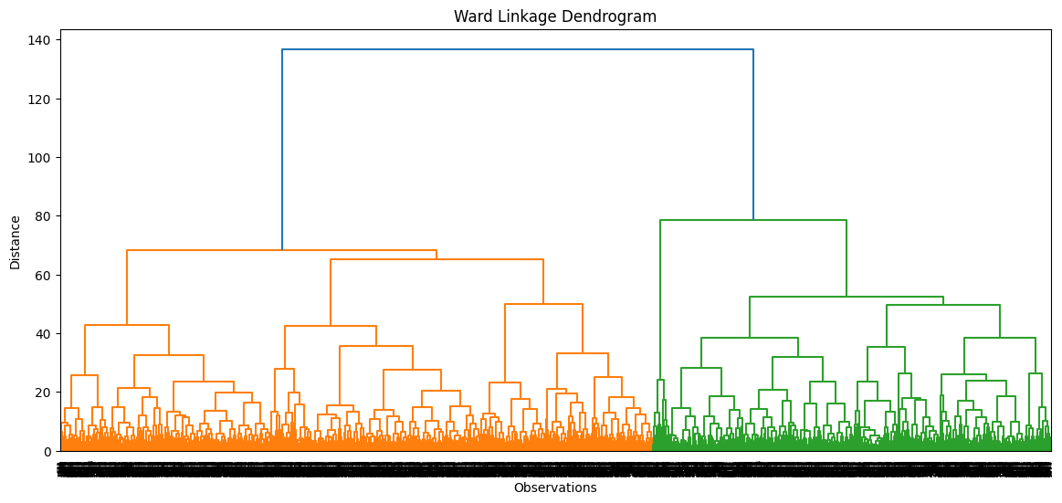
Ward linkage clustering merges clusters by minimizing the increase in within-cluster variance during the clustering process.

The Ward Linkage dendrogram produced the clearest and most interpretable clustering structure among all methods. Since Ward linkage minimizes within-cluster variance, it generated compact and well-separated clusters with clearer hierarchical relationships.
The resulting dendrogram visually demonstrated strong cluster separation and reduced overlapping between clusters,

Cophenetic Correlation Analysis
Cophenetic correlation analysis was conducted to evaluate how well each dendrogram preserved the original pairwise distances among observations.
Higher cophenetic correlation values indicate better preservation of the original distance structure and more accurate clustering representation.
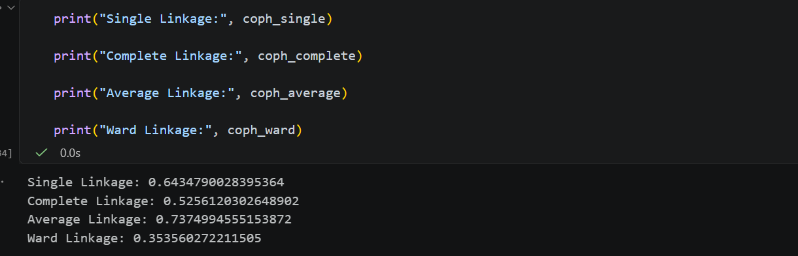
The cophenetic correlation values obtained for each linkage method are shown below:

The results indicate that Average Linkage produced the highest cophenetic correlation value (0.737), meaning that it preserved the original pairwise distance relationships more effectively than the other methods.
Although Ward Linkage produced visually clearer and more compact clusters, its cophenetic correlation value was lower compared to Average Linkage. Single Linkage showed moderate performance but suffered from chaining effects, while Complete Linkage produced compact clusters with moderate preservation of distances.
Therefore, based on cophenetic correlation analysis, Average Linkage was identified as the most accurate hierarchical clustering method for the white wine dataset.

Conclusion of part 2
The hierarchical clustering analysis successfully demonstrate the differences among several agglomerative clustering methods when applied to the white wine dataset.
The dendrogram visualizations revealed that different linkage methods produce different clustering structures and levels of cluster compactness.
Among the investigated methods:
- Single Linkage suffered from chaining effects.
- Complete Linkage produced compact clusters.
- Average Linkage provided balanced cluster structures and the highest cophenetic correlation.
- Ward Linkage generated visually clear and well-separated clusters.
Overall Average Linkage was identified as the best-performing hierarchical clustering method based on cophenetic correlation analysis, while Ward Linkage provided the most visually interpretable dendrogram structure.

